MAY 15th, 2024

PROTECT YOURSELF! COMBAT AIR POLLUTION WHILE SAFEGUARDING YOUR FAMILY'S HEALTH

## WELCOME TO GEOSPACE, WHERE WE ARE ALL ABOUT SAVING THE PLANET, ONE BREATH AT A TIME!

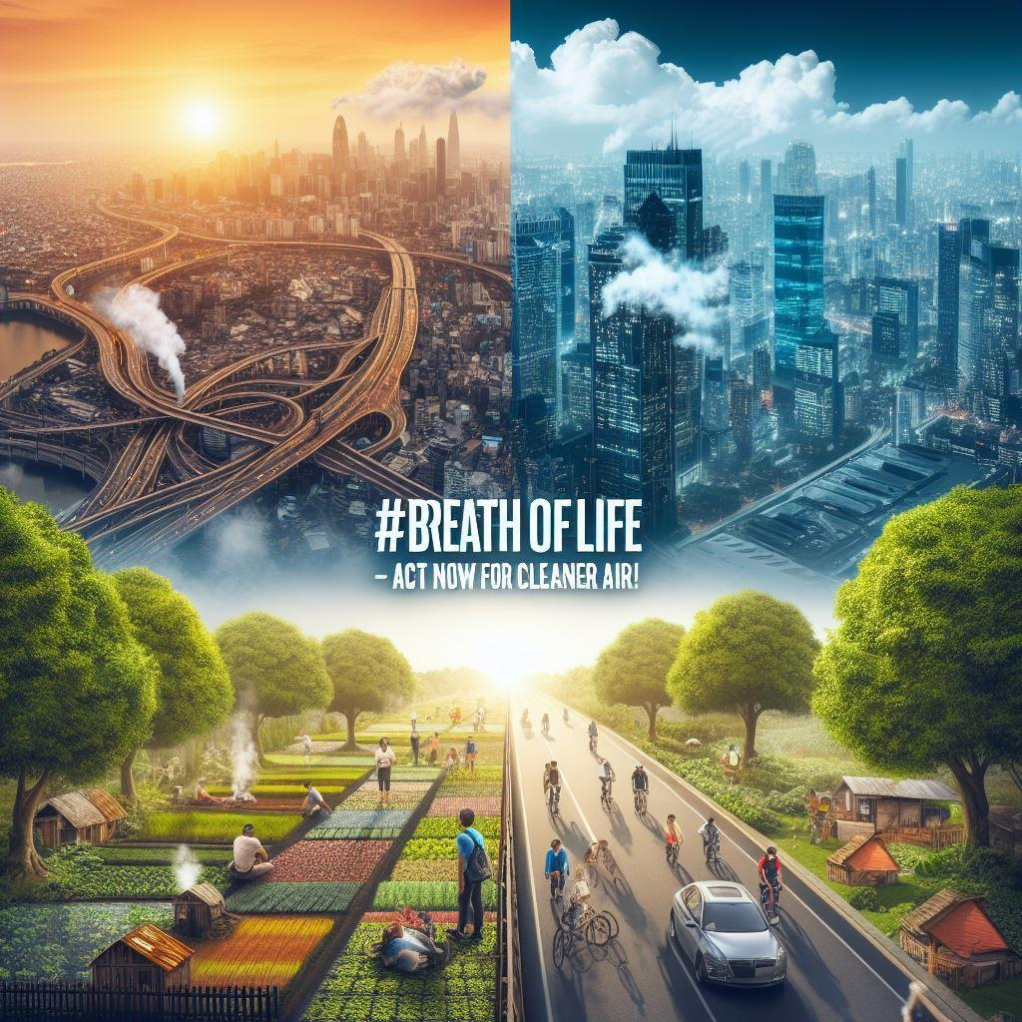

Afraid of your children becoming sick because of polluted air? Done with treating allergies and spending money on hospital bills? Then our “# BreathOfLife Global Campaign” is for you.

Our campaign is aimed at reducing air pollution and improving health while preserving our climate with clean air for generations to come.

Why Join the Campaign? According to the WHO, Air Pollution is one of the greatest environmental risks to health associated with 7 million premature deaths annually. But fear not! We can turn the tide with this initiative.

So How Do We Do It:

* Cleaner Air, Healthier Lives: By reducing air pollution, we are nit just saving our climate but also improving the quality of our lives and our families’.
* Climate Preservation: By removing one of the greatest risks to our ecosystem, we are all preserving our climate not just for ourselves but also for our generations to come.
* Join the Movement: By joining this campaign, you are creating a big difference in a lot of lives and in the world. So you can start by planning trees, using recyclable materials, or by spreading awareness.

So, what are you waiting for? Join GeoSpace and be a part of the solution! Together, we'll create a cleaner, greener world for all. 🌿 #BreatheEasyWithGeoSpace #MakingAChange